Project Title: Inventory Management System for Retailers Project Design Phase-I - Solution Fit Template Team ID: PNT2022TMID21428

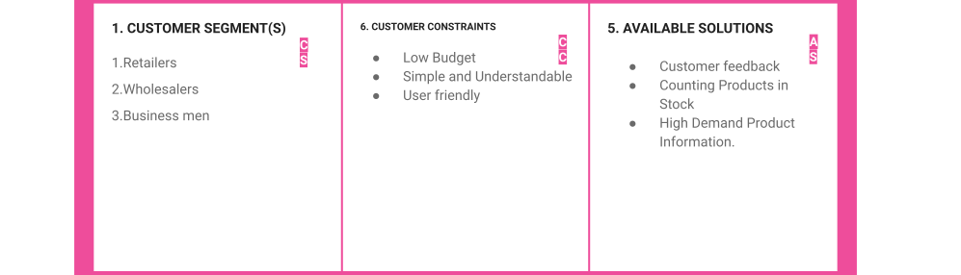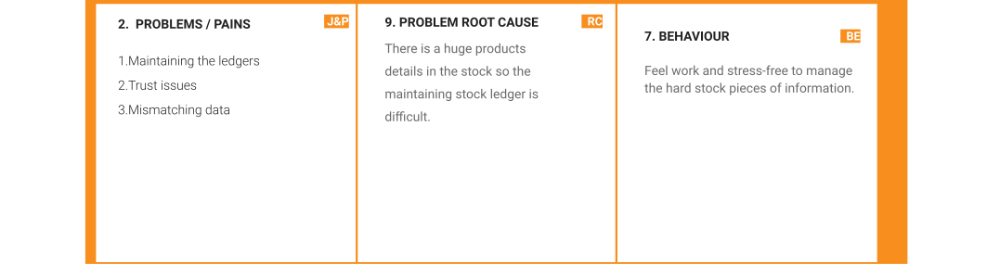

|  |  |  |  |  |
| --- | --- | --- | --- | --- |
|  | **3. TRIGGERS TR**  Hearing about the web application through social media, neighborhood retailers, and friends. | 1. **YOUR SOLUTION**   **SL**   * + Beneﬁting the retailers by scanning the product barcode and generating the invoice.   + By Collecting regular Orders and customer details the high-demand products will be identiﬁed. | 1. **CHANNELS of BEHAVIOR CH**    1. **ONLINE**   Check the Stock information whenever needed.   * 1. **OFFLINE**   Add a new variety of product details to the stock. |  |
| **4. EMOTIONS: BEFORE / AFTER**  BEFORE: Diﬃcult to maintain, Trust issues AFTER: More Proﬁt, Best Analysis |